D-Latch
A D-Latch is a basic digital logic circuit that is used to store a single bit of data. It is a simple device that has two inputs - a data input (D) and a control input (CLK) - and a single output (Q). When the control input is low (0), the output remains in its current state, regardless of the data input. When the control input is high (1), the output follows the state of the data input. In other words, a D-Latch is a type of flip-flop that allows you to latch (or store) a single bit of data, based on a clock signal.
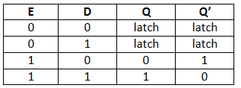

GRAY code
GRAY code, also known as reflected binary code, is a binary numeral system where two consecutive values differ in only one bit. In other words, each bit position in a GRAY code sequence changes only once, as opposed to a traditional binary code where all bits may change simultaneously. This property makes GRAY code useful in digital applications such as rotary encoders, error detection and correction codes, and analog-to-digital converters.

Special gate.
  - The special gate is a digital logic gate used to perform specific functions. The three types of special gates are:
  - XOR gate (Exclusive-OR gate): A gate that outputs a high (1) signal only when the inputs differ from each other, otherwise it outputs a low (0) signal.
  - XNOR gate (Exclusive-NOR gate): A gate that outputs a high (1) signal only when the inputs are the same, otherwise it outputs a low (0) signal.
  - NAND gate (Not-AND gate): A gate that outputs a low (0) signal only when both inputs are high (1), otherwise it outputs a high (1) signal.

Counter

Counter
A special type of sequential circuit used to count the pulse is known as a counter, or a collection of flip flops where the clock signal is applied is known as counters.
  - Counters are used in digital electronics for counting purpose, they can count specific event happening in the circuit.
  - A counter can follow the certain sequence based on our design like any random sequence 0,1,3,2… .They can also be designed with the help of flip flops.
  - The main properties of a counter are timing, sequencing , and counting.

Universal Gate.
A universal gate is a type of logic gate that can implement any Boolean function without the need for any other gate. It means that all other gates can be constructed from a universal gate. The two most common universal gates are the NAND gate and NOR gate.
The NAND gate can be used to implement all three basic gates: AND, OR, and NOT. When multiple NAND gates are connected, they can also implement more complex logic functions, such as XOR and XNOR gates.
The NOR gate is another universal gate that can implement any Boolean function. It can be used to create all three basic gates: AND, OR, and NOT. When multiple NOR gates are connected, they can also implement more complex logic functions, such as XOR and XNOR gates.

Flip-flop.
Flip-flop is a circuit that can store a single bit of data in digital electronics. It has two stable states, "0" or "1". Flip-flops are widely used in digital systems to implement various types of sequential logic circuits. They are often used to synchronize or control the timing of signals in digital systems.
There are four types of flip-flops, including SR flip-flop, D flip-flop, JK flip-flop, and T flip-flop. Each type of flip-flop has its own unique functionality and applications in digital circuits. For example, the D flip-flop is commonly used as a data storage element in registers and counters, while the JK flip-flop is used to implement more complex sequential circuits.

Half Adder
  - A half adder is a type of adder, an electronic circuit that performs the addition of numbers.
  - A half adder is used to add two single-digit binary numbers and results into a two-digit output.
  - The half adder is able to add two single binary digits and provide the output plus a carry value. It has two inputs, called A and B, and two outputs S (sum) and C (carry). The common representation uses a XOR logic gate and an AND logic gate.
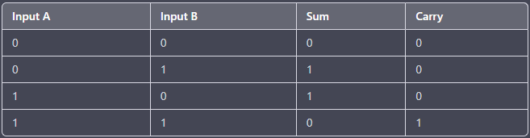
An example of a half adder circuit is shown below:
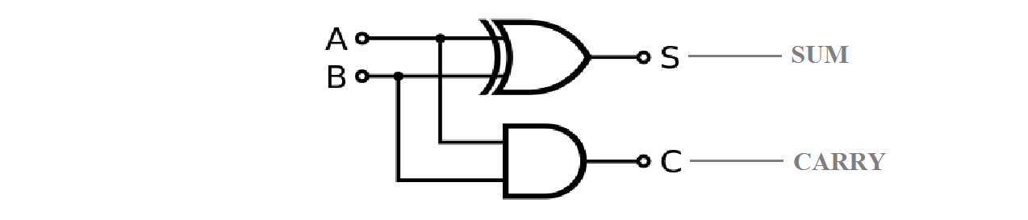
Where A and B are the input bits, S is the output sum, and C is the output carry.

Full Adder
- A full adder is a digital circuit that performs addition.
- A full adder is used to add three single-digit binary numbers and results into a two-digit output.
- Full adder has three inputs, A, B and Z and two outputs S (sum) and C (carry).
- Full adders are implemented with logic gates in hardware. Full adders are made from XOR, AND and OR gates in hardware. Full adders are commonly connected to each other to add bits to an arbitrary length of bits, such as 32 or 64 bits.
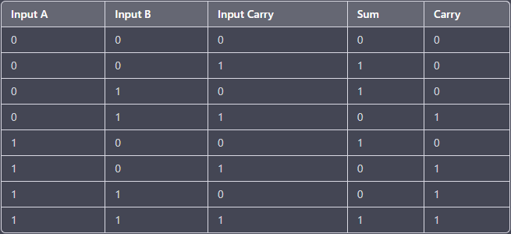
An example of a full adder circuit is shown below:
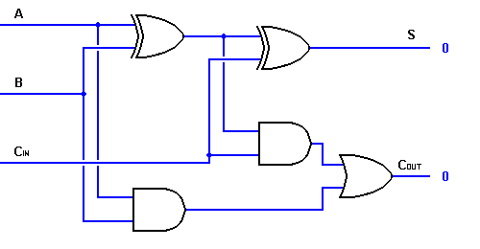
Where A and B are the input bits, C is the input carry, S is the output sum, and C is the output carry.

Shift Register
A shift register is a sequential circuit that is used to store and shift data in a controlled manner. It can be thought of as a chain of flip-flops connected in series, with the output of one flip-flop connected to the input of the next. The data is loaded into the first flip-flop, and then shifted down the chain one bit at a time on each clock cycle.
There are four basic types of shift registers:
  - Serial-in, Serial-out (SISO) shift register: It has a single input and a single output. Data is entered serially, one bit at a time, and shifted out in the same way. Example: 74LS164.
  - Parallel-in, Serial-out (PISO) shift register: It has multiple inputs and a single output. Data is entered in parallel, with each bit on a separate input, and shifted out in serial form. Example: 74LS166.
  - Serial-in, Parallel-out (SIPO) shift register: It has a single input and multiple outputs. Data is entered serially, and then latched into the flip-flops. The data is then available in parallel form at the outputs. Example: 74LS165.
  - Parallel-in, Parallel-out (PIPO) shift register: It has multiple inputs and multiple outputs. Data is entered in parallel, and then shifted out in parallel form. Example: 74LS194.
Shift registers are used in a variety of applications, including data storage, data transmission, and signal processing. For example, they can be used to store and shift out data from a sensor array, to implement a delay line for audio or video signals, or to perform serial-to-parallel or parallel-to-serial conversions.

K-map

Karnaugh map
Karnaugh map or K-map is a map of a function used in a technique used for minimization or simplification of a Boolean expression. It results in a smaller number of logic gates and inputs to be used during the fabrication.
Booleans expression can be simplified using Boolean algebraic theorems but there are no specific rules to make the most simplified expression. However, K-map can easily minimize the terms of a Boolean function.

4 Variable K-Map
The number of cells in 4 variable K-map is sixteen, since the number of variables is four. The following figure shows 4 variable K-Map.
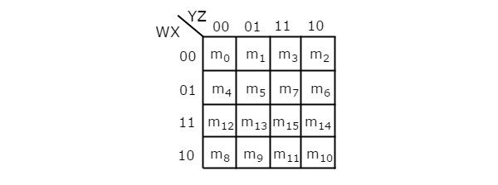
- There is only one possibility of grouping 16 adjacent min terms.

Logic Gate
The basic digital electronic circuit that has one or more inputs and single output is known as Logic gate. Hence, the Logic gates are the building blocks of any digital system. We can classify these Logic gates into the following three categories.
  - Basic gates
  - Universal gates
  - Special gates

AND Gate
An AND gate is a digital circuit that has two or more inputs and produces an output, which is the logical AND of all those inputs. It is optional to represent the Logical AND with the symbol ‘.’.
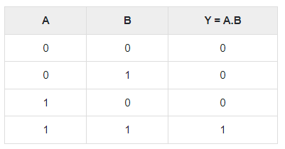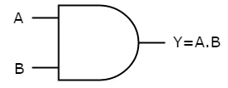
Here A, B are the inputs and Y is the output of two input AND gate. If both inputs are ‘1’, then only the output, Y is ‘1’. For remaining combinations of inputs, the output, Y is ‘0’.

OR Gate
An OR gate is a digital circuit that has two or more inputs and produces an output, which is the logical OR of all those inputs. This logical OR is represented with the symbol ‘+’.
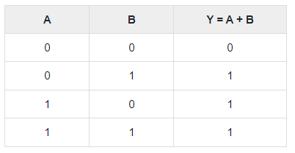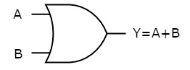
Here A, B are the inputs and Y is the output of two input OR gate. If both inputs are ‘0’, then only the output, Y is ‘0’. For remaining combinations of inputs, the output, Y is ‘1’.

NOT Gate
A NOT gate is a digital circuit that has single input and single output. The output of NOT gate is the logical inversion of input. Hence, the NOT gate is also called as inverter.
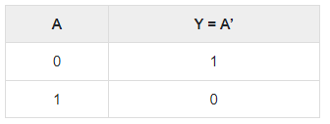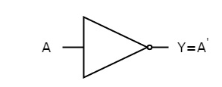

Special Gates
Ex-OR & Ex-NOR gates are called as special gates. Because, these two gates are special cases of OR & NOR gates.

Ex-OR Gate
The full form of Ex-OR gate is Exclusive-OR gate. Its function is same as that of OR gate except for some cases, when the inputs having even number of ones.
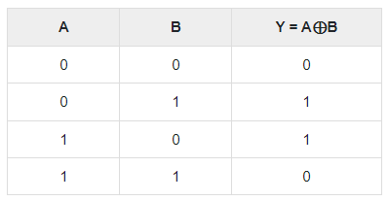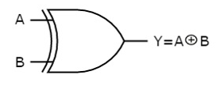
The output of Ex-OR gate is ‘1’, when only one of the two inputs is ‘1’. And it is zero, when both inputs are same.

Ex-NOR Gate
The full form of Ex-NOR gate is Exclusive-NOR gate. Its function is same as that of NOR gate except for some cases, when the inputs having even number of ones.
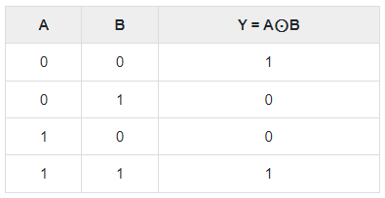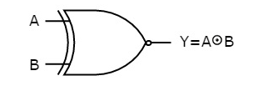
Therefore, the output of Ex-NOR gate is ‘1’, when both inputs are same. And it is zero, when both the inputs are different.

